Name ___________________________ Block _____ English 9

The literary term project counts as a test grade.

Onomatopoeia: Words such as sputter, spurt, bang, and crash imitate the sounds associated with the objects or actions to which they refer.

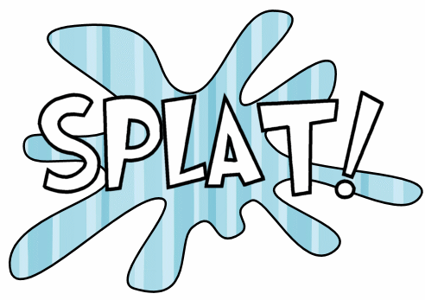
Directions: Below are two great examples of poetry that use onomatopoeia. Read over the examples and then:
- create your own poem
- be sure your poem tells a story
- be sure to include an illustration with your poem’s final copy
The Rusty Spigot
The rusty spigot
sputters,
utters
a splutter,
spatters a smattering of drops,
gashes wider;
slash,
splatters,
scatters,
spurts,
finally stops sputtering
and plash!
gushes rushes splashes
clear water dashes.

Poem 2
Cafeteria
Boom!
Went the food
trays.
Clap! Clap!
Goes the teacher.
Rip!
Went the
plastic bag.
Munch! Munch!
Go the students. Slurp!!!
Went the straws.
Whisper
Is what half the kids
in the room
are doing.
Crunch!
Crunch!
go
the candy bars.
Begin your rough copy below:

________________________________________________________________________
____________________________________________________________________________________________________________________________________________________________________________________________________________________________________________________________________________________________________________________________________________________________________________________________________________________________________________________________________________________________________________________________________________________________________________________________________________________________________________________________________________________________________________________________________________________________________________________________________________

