English 9
SHORT STORY ELEMENTS

1. SETTING -- The time and location in which a story takes place is called the setting. Several aspects from which to consider in a setting:
a) place - geographical location. Where is the action of the story taking place?
b) time - When is the story taking place? (historical period, time of day, year, etc)
c) weather conditions - Is it rainy, sunny, stormy, etc?
d) social conditions - What is the daily life of the characters like? Does the story contain local colour (writing that focuses on the speech, dress, mannerisms, customs of a particular place)?
e) mood or atmosphere - What feeling is created at the beginning of the story? Is it bright and cheerful or dark and frightening?

2. PLOT -- The plot is how the author arranges events to develop his basic idea; It is the sequence of events in a story or play. The plot is a planned, logical series of events having a beginning, middle, and end. The short story usually has one plot so it can be read in one sitting. There are five essential parts of plot:
a) Introduction - The beginning of the story where the characters and the setting is revealed.
b) Rising Action - This is where the events in the story become complicated and the conflict in the story is revealed (events between the introduction and climax).
c) Climax - This is the highest point of interest and the turning point of the story. The reader wonders what will happen next; will the conflict be resolved or not?
d) Falling action - The events and complications begin to resolve themselves. The reader knows what has happened next and if the conflict was resolved or not (events between climax and denouement).
e) Resolution/Denouement - This is the final outcome or untangling of events in the story.
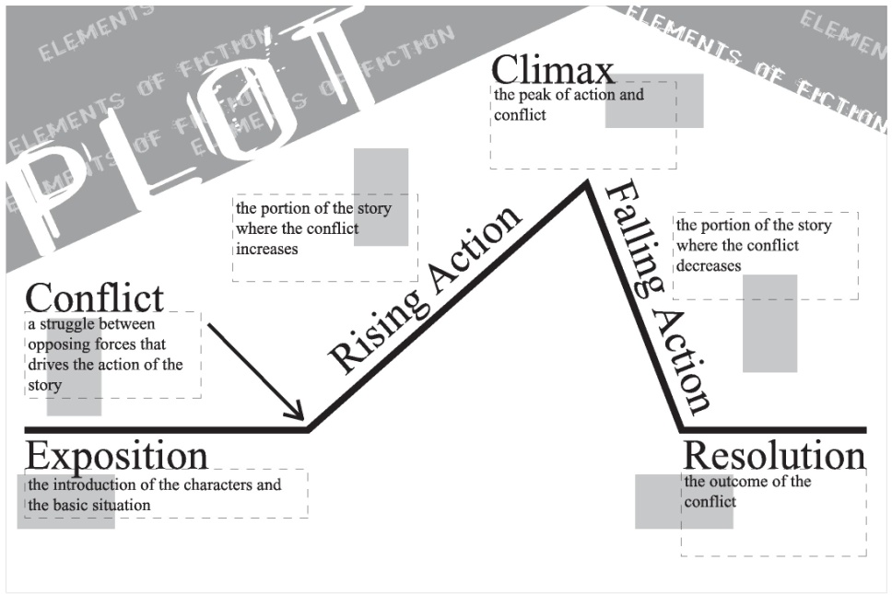

3. CONFLICT- Conflict is essential to plot and without conflict there is no plot. It is the opposition of forces which ties one incident to another and makes the plot move. Conflict is not merely limited to open arguments, rather it is any form of opposition that faces the main character. Within a short story there may be only one central struggle, or there may be one dominant struggle with many minor ones.
There are two types of conflict:

1.) External - A struggle with a force outside one's self.
2.) Internal - A struggle within one's self; a person must make some decision, overcome pain, quiet their temper, resist an urge, etc.

There are four kinds of conflict:
a) Man vs. Man (physical) - The leading character struggles with his physical strength against other men/women, forces of nature (environment), or animals.
b) Man vs. Circumstances (classical) - The leading character struggles against fate, or the circumstances of life facing him/her.
c) Man vs. Society (social) - The leading character struggles against ideas, practices, or customs of other people.
d) Man vs. Himself/Herself (psychological) - The leading character struggles with himself/herself; with his/her own soul, ideas of right or wrong, physical limitations, choices, etc.

4. CHARACTER -- There are two meanings for the word character: (1.) The person in a work of fiction. (2.) The characteristics of a person.
Persons in a work of fiction - Antagonist and Protagonist - Short stories use few characters. One character is clearly central to the story with all major events having some importance to this character - he/she is the PROTAGONIST. The opposing force or character opposing the main character is called the ANTAGONIST.
5 Types of Characters:
A. Flat Character: A flat character is a character which may be summed up by one or two traits. He received limited development at the hands of the author.
B. Round Character: A round character is a character who is complex and many-faceted, and thus realistic. The author developed this character fully.
C. Static Character: A static character is one who is the same at the end of the story as at the beginning. He does not undergo any basic personality changes.
D. Dynamic Character: A developing character who undergoes a permanent change in her personality as a result of the situation presented in the story.
E. Stock Character: A stock character is a stereotyped character, whose characteristics are immediately known because of common conceptions (or misconceptions) about certain groups of people.

5. POINT OF VIEW
Point of view, or “P.O.V”, is defined as the angle from which the story is told.
1. First Person - Story is told by the protagonist or one of the characters who interacts closely with the protagonist or other characters (using pronouns I, me, we, etc). Reader sees the story through this person's eyes as he/she experiences it and only knows what he/she knows or feels.
2. 3rd Person Omniscient- The author can narrate the story using the omniscient point of view. He can move from character to character, event to event, having free access to the thoughts, feelings and motivations of his characters and he introduces information where and when he chooses. There are two main types of omniscient point of view:
3. 3rd Person Limited Omniscient - The author tells the story in third person (using pronouns they, she, he, it, etc). We know only what the character knows and what the author allows him/her to tell us. We can see the thoughts and feelings of characters if the author chooses to reveal them to us.
4. Objective - the narrator is simply a 'fly on the wall' doesn't know what anybody is thinking, only sees what is going on.

6. Symbolism: any object, person, place, or action that has a meaning in itself and that also stands for something larger than itself, such as a quality, an attitude, a belief, a value
(e.g., spring symbolizes youth; a dove symbolizes peace).

7. Foreshadowing: an author’s use of hints or clues to suggest events that will occur later in the narrative.

8. Flashback: an interruption in the narrative to show an episode that happened before that particular point in the story.

9. Tone: the author’s attitude or feeling toward a person, thing, place, event, or situation

10. Irony: something which is said or done unexpectedly; not as harsh or obvious as sarcasm

3 Types of Irony:
- verbal irony: contrast between what is said and what is actually meant.

- situational irony: refers to a happening that is the opposite of what is intended or expected.

- dramatic irony: occurs in situations where the audience knows something about present or future circumstances that the character does not know.

11. THEME - The theme in a piece of fiction is its controlling idea or its central insight. It is the author's underlying meaning or main idea that he is trying to convey. The theme may be the author's thoughts about a topic or view of human nature. The title of the short story usually points to what the writer is saying and he may use various figures of speech to emphasize his theme, such as: symbol, allusion, simile, metaphor, hyperbole, or irony.

Some simple examples of common themes from literature, TV, and film are:
- things are not always as they appear to be
- Love is blind
- Believe in yourself
- People are afraid of change
- Don't judge a book by its cover (more of a moral)

