Choose a sport and research the technological advancements over time and the advantages these have had on performance. Start with the earliest to the latest progressions in technology.

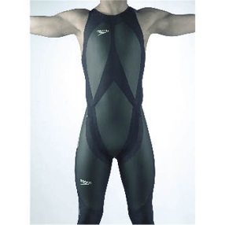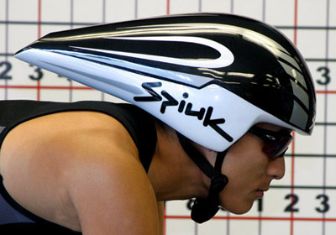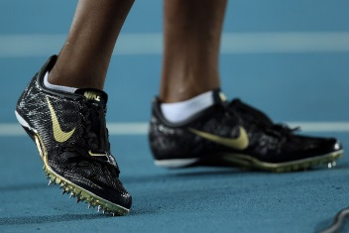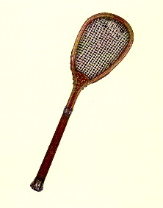

Sport:

Technological Advancement | Performance Advantage | Year Introduced

